DRAFT SECTION OF SENTENCING MEMORANDUM REQUESTING SHORTER PROBATIONARY PERIOD

A long probationary period for [CLIENT] would be counterproductive, because social science research shows that lengthy probationary sentences do not promote public safety or enhance rehabilitation goals. See United States v. Doyle, 711 F.3d 729, 734 (6th Cir. 2013) (noting that the twin goals of probation are “rehabilitation of the defendant [] and the protection of the public”). Instead, a longer probationary period in this case will simply cost the State more money, spread the probation department thinner, and unnecessarily prolong [CLIENT’s] sentence. Research shows that probation periods that are not goal-oriented and that exceed one year in length are unnecessary due to diminishing marginal returns. After the goals of probation have been achieved or a year without reoffending has passed, probation does not significantly improve public safety, reduce recidivism, or further additional rehabilitative goals. It just costs the State more money and overwhelms probation agents with increasingly bloated caseloads that make them less able to provide effective supervision for those who need it.
For these reasons, [CLIENT] respectfully requests that this Court impose a goal-oriented probationary sentence that terminates upon completion of [INSERT OUTCOME-ORIENTED GOAL]. If this Court is inclined to impose a time-driven period of probation, [CLIENT] respectfully requests that it impose a one-year probationary period.
- Research shows that probationary periods are more effective when they are goal-driven rather than time-driven.

“[P]robation should be only long enough to meet its basic objectives of providing accountability proportional to the underlying criminal offense, connecting people to needed treatment and services, and enabling individuals to complete programs such as cognitive behavioral therapy and counseling that have been shown to reduce the risk of re-offending.” Jake Horowitz & Tracy Velazquez, States can Shorten Probation and Protect Public Safety, The Pew Charitable Trusts 2 (December 3, 2020) [hereinafter “Pew Study”]. Researchers at the PEW Charitable Trusts along with data analysts at Maxarth LLC conducted a wide-ranging study to investigate how effectively probationary sentences of different lengths and kinds impacted public safety outcomes. See id. This led researchers to recommend implementing goal-based instead of time-based supervision.
“Goal-based supervision works by setting clear expectations for probationers or parolees that they must either complete specific requirements or maintain general compliance with all conditions of supervision, and that if they do so, they will be rewarded with an early discharge or termination from supervision.” Goal Based Supervision, Robina Institute of Criminal Law and Criminal Justice, at 1 (July 2020) [hereinafter “Robina Study”]. A goal-based probationary period is designed to encourage probationers to demonstrate their compliance in ways that earn them time credit while simultaneously promoting their rehabilitation and ultimately leading to early discharge when successful. For example, in Texas, a probationer can receive time reductions for earning education degrees, paying court fees, and successfully completing treatment programs. Vernon’s Ann. Texas C.C.P. Art. 42A.702 (2019). Goal-based supervision recognizes that behavior is learned and “can be influenced by environmental manipulation, such as sanctions and incentives for different behavior.’ Robina Study, supra, at 2. Behavioral science indicates that goal-based probation encourages individuals to comply with conditions and results in lower rates of recidivism when compared to those who serve time-based supervision terms. Id.
Standard probation conditions are often voluminous, non-discrete, and contain wide-ranging conditions (i.e. obeying every local ordinance in New Jersey, including not flying kites in parks and not feeding pigeons in public) that are not aimed at the twin goals of probation. These broad, non-tailored conditions often serve no public safety or rehabilitation end. See Fiona Doherty, Obey All Laws and Be Good: Probation and the Meaning of Recidivism, 104 Geo. L.J. 291, 291 (2016) (concluding based on a study done by a Yale Law Professor that standard probationary sentences “make a variety of noncriminal conduct punishable with criminal sanctions [and] construct a definition of recidivism that contributes to overcriminalization”). In contrast, goal-based probationary sentences do not assign an arbitrary term of months and conditions; instead, successful completion of probation is measured by a participant completing an individually-tailored set of programming goals. This encourages positive behavioral changes: the sooner a probationer achieves their goals, the sooner supervision ends. By releasing clients from probation when they achieve specific goals, the state will prevent the unnecessary bloating of probationary caseloads.
Here, [CLIENT] should be sentenced to a goal-based probationary sentence that will be terminated after the completion of the prescribed programming. [INSERT INFORMATION HERE ABOUT THE GOALS OF PROBATION FOR YOUR CLIENT, HOW THOSE GOALS CAN BE MEASURED DURING PROBATION, AND WHAT SATISFACTORY GOAL COMPLETION LOOKS LIKE.] All of this work will be done in partnership with [CLIENT]’s probation officer. When [CLIENT] has completed this programming and their probation officer is satisfied with their progress, probation should be terminated.
- A longer probationary term is unnecessary, because research shows that longer probationary terms do not improve public safety or reduce recidivism.

Alternatively, if the Court is inclined to impose a time-based period of probation, [CLIENT’s] probation should terminate after one year of successful supervision without reoffending, because research shows that individuals who are arrest-free for their first year of probation do not require longer probation sentences to serve the twin goals of probation – rehabilitation and protection of the public. Researchers in the Pew Study used data from states with average probationary terms that hovered around the two-year mark (which is the approximate length of the average probationary term nationally) and compared individuals who were on probation for a year or less with individuals who were on probation for longer. Pew Study, supra at 9-10. They found that the rehabilitative and public safety goals of probation were adequately achieved for a majority of probationers by the end of the first year of probation, such that most probationers’ terms could have been shortened to a year without affecting recidivism. Id.
More specifically, the researchers collected data from South Carolina (2010-2013) and Oregon (2010-2014) – two states with average probationary terms similar to the national average of 22.4 months (Oregon = 24 months; South Carolina = 26.2 months). Id. at 4-5. Relying on data from the Bureau of Justice Statistics Annual Probation and Annual Parole surveys, the researchers created a statistical profile of each person on probation using data points “known to be linked to re-offending.” Id. at 9. These data points included individuals’ criminal histories, demographic data, risk assessment scores, and other discharge information. The researchers then matched individuals who had been discharged from probation with individuals who had similar statistical profiles but were still on probation. They compared the matched individuals’ recidivism outcomes by collecting data about rearrests at 12, 18, 24, and 30 months. Id. at 9. The results in both states were telling: 53% of individuals on probation in Oregon and 61% of individuals on probation in South Carolina could serve terms that were shortened by a year or more without negatively impacting recidivism rates. And nine in ten people who completed their first year on probation without being re-arrested “could have spent at least three fewer months under supervision than they actually did with no negative impact on recidivism, and many could have served much less time.” Id. at 9. See Figure 1.
Figure 1. Percentage of individuals whose terms of probation could have been shortened, by months of reduction. A majority of those who were arrest-free for their first year of supervision could have had their probation shortened by more than a year.

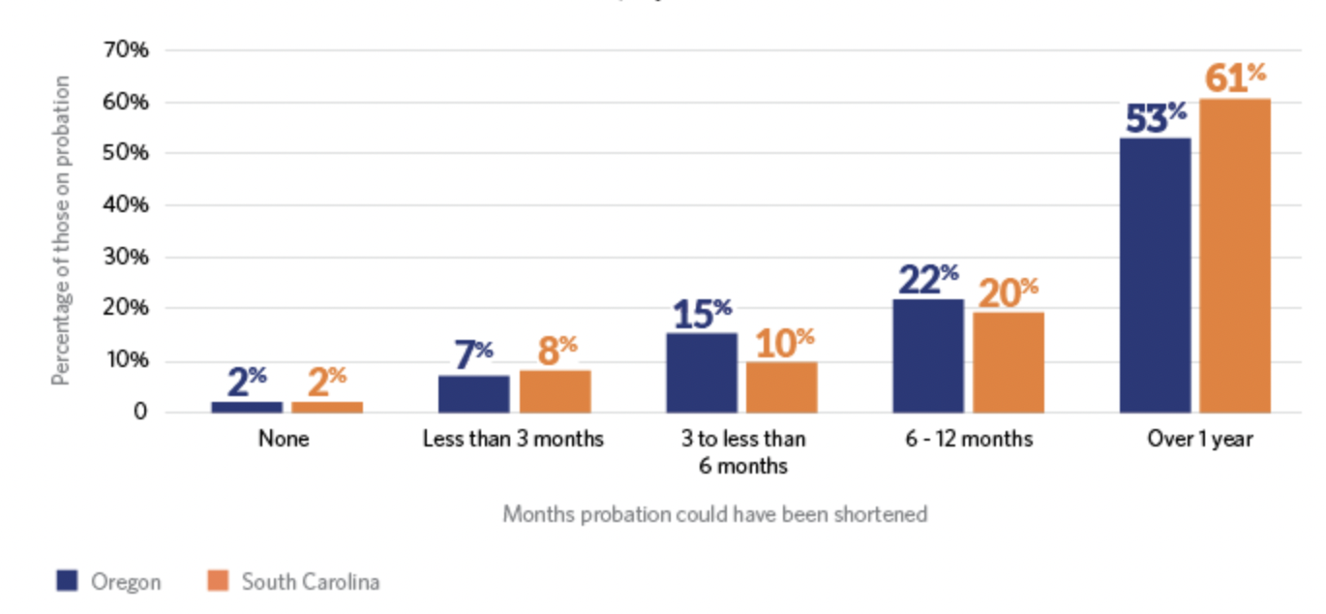

This study suggests that individuals who are arrest-free for their first year of probation are sufficiently rehabilitated and that their probation terms could end at that point without compromising their rehabilitation and without compromising public safety. “[A]fter the first year, many supervision provisions, such as reporting requirements and community-based services, have little effect on the likelihood of re-arrest, so keeping probation terms short and prioritizing resources for early stages of supervision can help improve success rates among people on probation . . . and protect public safety.” Id. at 2. A person who successfully completes a full year of probation is at a much lower risk of reoffending. At the one-year mark, if [CLIENT] has successfully followed the conditions of probation, there is little utility in further extending supervision.
In fact, extension of probation beyond that point could actually be harmful. Research shows that “subjecting low risk individuals to intensive supervision or treatment leads to worse outcomes than no intervention.” Jake Horowitz, Michael Williams & Connie Utada, Policy Reforms Can Strengthen Community Supervision, The PEW Charitable Trusts, at 4 (April 2020); see also United States v. Trotter, 321 F.Supp.3d 337, 340 (E.D.N.Y. 2013) (cautioning courts that “careful attention should be given to the potential of [probation], and its duration, to help—or to prevent—rehabilitation” (emphasis added)).
Thus, the data indicate that a period of probation beyond a year is more than what is necessary to guarantee that [CLIENT] is rehabilitated and that the public is properly protected and may actually be counterproductive. If [CLIENT] can satisfactorily complete a shorter period of goal-driven probation, early termination will serve the rehabilitative goals of probation without any compromise to public safety.
- Shorter probationary periods save the State money and enable probation officers to better perform their supervisory functions by preventing the system from being overwhelmed.

Shorter probationary periods would prevent the state from unnecessarily wasting precious resources and would allow for more targeted supervision that would prevent the probation system from being overwhelmed while still fully serving the probation system’s rehabilitative and public safety goals. National trends toward lengthy probation sentences have caused the population of individuals on probation to explode in recent years. See Figure 2.
Figure 2. National trends in U.S. Probation, Jail, and Prison population (1980-2014). The population of individuals on probation far exceeds the number of individuals in jail and prison.
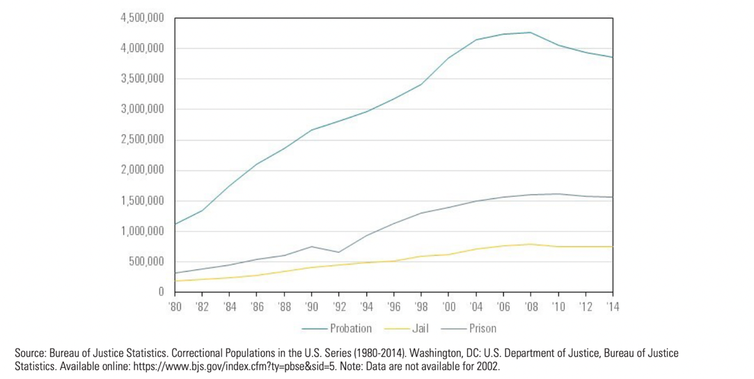

Having more individuals on probation for longer periods of time requires the state to bear “unnecessary and unproductive costs and waste[] scarce resources.” Pew Study, supra at 2. For example, during the time of the PEW study, Oregon paid $12 a day for each individual on probation. Vikrant P. Reddy & Marc A. Levin, Protecting Public Safety and Reducing Correctional Costs in Oregon, Cascade Policy Institute, at 2 (March 2013). With approximately 24,323 individuals on probation at any given time, the state paid almost $300,000 a day for supervision of their probationers. Pew Study, supra, at 12. If individuals who were arrest-free for a year or more had served reduced terms, Oregon’s daily probation population could have been reduced to 13,697. Id. That would have cut Oregon’s daily probationary costs almost in half. [INSERT YOUR JURISDICTION’S COSTS IF YOU HAVE ACCESS TO THEM.]
Placing people on probation for unnecessarily long periods of time also has important detrimental effects on the probation system’s ability to achieve its rehabilitative goals, because it prevents agents from being able to spend time with clients and design individually tailored plans. Research shows that “state and local agencies tasked with administering community supervision often struggle to provide alternatives to incarcerating that are effective in reducing re-offending.” Pew Study, supra, at 22. A subsequent PEW Charitable Trusts study revealed that, “[a]s caseloads grow, many agencies struggle to prioritize supervision and services for individuals at high risk of reoffending as well as those with significant needs related to substance misuse, housing instability, or financial insecurity . . . . [P]robation and parole officers often lack sufficient resources to promote success for the people who are most likely to fail on supervision.” Jake Horowitz, Michael Williams & Connie Utada, Policy Reforms Can Strengthen Community Supervision, The PEW Charitable Trusts, at 4 (April 2020). Thus, shorter probationary periods enable probation agents to better support both the rehabilitative and public safety goals of probation.
There is also reason to believe that probation departments are currently overwhelmed. This, in turn, has led to probation agents feeling more job-related stress and facing burnout, which also compromises their effectiveness. See, e.g., Peter Finn & Sarah Kuck, Addressing Probation and Parole Officer Stress, Final Report, National Institute of Justice, at 2 (September 25, 2003) (“Research strongly suggests that many probation and parole officers experience considerable job-related stress, especially in terms of: high caseloads, excessive paperwork, and meeting deadlines.”). A reduced probationary caseload for state agencies will allow for more creative, targeted, hands-on, and effective supervision for those who need it the most without compromising public safety.
* * *
Despite probation originating as a means of reintegration, the “sinister side of probation” is that, while it includes a “promise of redemption,” it is constantly “subverted by a lurking punitiveness.” Nora V. Demleitner, How to Change the Philosophy and Practice of Probation and Supervised Release: Data Analytics, Cost Control, Focus on Reentry, and a Clear Mission, 28 Fed. Sent'g Rep. 231, 232 (2016). Probation should not be a punishment. Rather, it is a way to help rehabilitate individuals and acclimate those returning to society while simultaneously protecting the public. Research shows that these goals can be effectively served through a shorter goal-oriented probationary period, which also saves the state’s resources and enables probation departments to better perform their intended functions.
For these reasons, [CLIENT] respectfully requests that this Court impose a goal-oriented probationary sentence that terminates upon completion of [INSERT OUTCOME-ORIENTED GOAL]. If this Court is inclined to impose a time-driven period of probation, [CLIENT] respectfully requests that it impose a one-year probationary period.

